**IoT Based Smart Parking System**

TEAM:Aayush Tiwari,Yash Thaman,Sachin YAdav

Table of Contents

Abstract:

Acknowledgements

# INTRODUCTION

* 1. **Introduction To IoT Based Smart Parking System………………………………….6**
  2. **Characterstics Of Smart Parking System…………………………………………….7**
  3. **General application and description of the project………………………………….7**
  4. **Working of circuit and image of the model…………………………………….…….7**
  5. **Connection for the IR Sensors……………………………………….……….……….8**
  6. **Block Diagram……………………………………………………………….…………8**
  7. **Description of the circuit…………………………………………………….…………9**
  8. **Component of Smart Parking system…………………………………………………9**

1. **Arduino Uno………………………………………………………...………….9**
2. **IR Sensors………………………………………………………………………10**
3. **ESP8266 Module………………………………………………………………11**
4. **7805 IC…………………………………………………………………………12**
5. **Relay Module…………………………………………………………………..13**
6. **Led………………………………………………………………………………15**
7. **Transistor……………………………………………………………………….15**
8. **Resistance……………………………………………………………………….16**
9. **Printed Circuit Board (PCB)…………………………………………………..17**
10. **Battery…………………………………………………………………………...18**
    1. **Applications……………………………………………………………….19**
11. **LITERATURE SURVEY…………………………………………20**
    1. **Introduction………………………………………………………………20**
    2. **Data Gathering……………………………………………………………21**
12. **THE PROPOSAL/METHEDOLOGY**
    1. **Introduction……………………………………………………………………22**
    2. **Panoramic View Of the Methodology………………………………………..23**
13. **SIMULATION RESULTS AND ANALYSIS**
    1. **Introduction…………………………………………………………………..25**
       1. **Technical Overview……………………………………………………..25**
       2. **Characteristics…………………………………………………………25**
    2. **Working Of Application……………………………………………………….26**
14. **Conclusion And Future Scope**
    1. **Conclusion…………………………………………………………….27**
    2. **Future Scope…………………………………………………………...27**

**5.2.1 Moving Towards Automation…………………………………………28**

**5.2.2 Development And Deployment………………………………………...29**

**REFERENCES………………………………………………………………30**

**LIST OF FIGURES**

**Figure 1 High Level View Of IoT** 6

Figure 2 8

Figure 3 8

Figure 4 8

**Figure 5 Arduino UNO** 9

**Figure 6 IR Sensor** 10

Figure 7 10

**Figure 8 ESP8266** 11

Figure 9 ESP With Wi-Fi Module 12

**Figure 10 7805 IC** 12

**Figure 11 Relay Module** 13

**Figure 12 Relay Connections** 14

Figure 13 Pin Wiring 14

Figure 14 LED 15

Figure 15 Transistor 16

Figure 16 Resistance 17

Figure 17 PCB 17

Figure 18 21

**ABSTRACT**

This paper introduces a novel algorithm that increases the efficiency of the current cloud-based smart-parking system and develops a network architecture based on the Internet-of-Things technology. This paper proposed a system that helps users automatically find a free parking space at the least cost based on new performance metrics to calculate the user parking cost by considering the distance and the total number of free places in each car park. This cost will be used to offer a solution of finding an available parking space upon a request by the user and a solution of suggesting a new car park if the current car park is full. The simulation results show that the algorithm helps improve the probability of successful parking and minimizes the user waiting time. We also successfully implemented the proposed system in the real world.

Now days in many multiplex systems there is a severe problem for car parking system. There are many lanes for car parking, to park a car one has to look for the all lanes. Moreover there is a lot of men labor involved for this process for which there is lot of investment. So the need is to develop a system which indicates directly which parking slot is vacant in a lane.

This project is IOT based intelligent car parking system, where it shows the state of availability of each parking space. User can book his slot before reaching to desired destination through mobile application provided that allows an end user to check the availability of parking space and then book a parking slot accordingly.

This project is divided into four major parts – Power supply, Controller, Input and Output, where:

1. Power supply – Battery / Adaptor
2. Controller – Microcontroller Atmega 328
3. Input – IR sensor
4. Output – Wi-Fi module & LEDs

User can check the availability of parking through a mobile application where he can select prepaid booking before reaching destination. In parking slot, red light indicates space booked, green light indicates vacant and yellow light indicates prepaid booking. When a car is parked on particular space there is IR sensor placed on that area. Red led will glow through IR sensor as space is booked. As it is moved from IR sensor, Led will turn into green led as vacant space. All these functions will be functioning through app and user can book his space before reaching destination and can save time.

# CHAPTER 1

**INTRODUCTION**

This paper introduces a novel algorithm that increases the efficiency of the current cloud-based smart-parking system and develops a network architecture based on the Internet-of-Things technology. This paper proposed a system that helps users automatically find a free parking space at the least cost based on new performance metrics to calculate the user parking cost by considering the distance and the total number of free places in each car park. This cost will be used to offer a solution of finding an available parking space upon a request by the user and a solution of suggesting a new car park if the current car park is full. The simulation results show that the algorithm helps improve the probability of successful parking and minimizes the user waiting time. We also successfully implemented the proposed system in the real world.

Moving towards smart city application, smart parking is a good example for a common citizen of how the Internet-of-Things (IoT) will be effectively and efficiently used in our daily living environments to provide different services to different users. Any citizen may use his mobile device, a computer having Internet to access the smart city application from anywhere in the world to find a free parking spot in the city and get to know the which parking spot is still available. It provide efficient car parking management through remote parking spot localization and fast car retrieval. Presently, Car parking system is based on reservation basis, but this system has a drawback in terms of time and space. This project management system can be grouped into multi-parking management which can be used to manage both outdoor and indoor parking area and singleparking management which usually targets indoor parking lots[6]. The focus and objective of this project work lies on mono-parking management architectural system which works on real-time basis. This paper is organized as follows: Section II presents the important concepts related to IoT. The proposed system is introduced in Section III and is being evaluated in Section IV. Finally, the proposed system result is concluded in Section V.

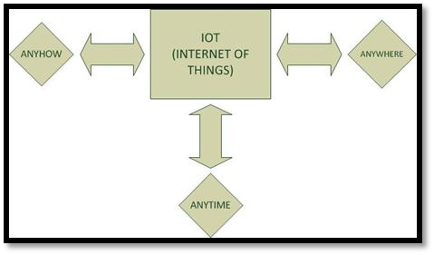

**Figure 1 High Level View Of IoT**

* 1. **INTRODUCTION TO IoT BASED SMART PARKING SYSTEM**

In the development of traffic management systems, an intel- advantage of the significant development in technology, the ligent parking system was created to reduce the cost of Internet-of-Things technology (IoT) has created a revolution hiring people and for optimal use of resources for car-park in many fields in life as well as in smart-parking system (SPS) owners. Currently, the common method of finding a parking technology [20]. The present study proposes and develops space is manual where the driver usually finds a space in an effective cloud-based SPS solution based on the Internet the street through luck and experience. This process takes of Things. Our system constructs each car park as an time and effort and may lead to the worst case of failing IoT network, and the data that include the vehicle GPS locato find any parking space if the driver is driving in a tion, distance between car parking areas and number of free city with high vehicle density. The alternative is to find a slots in car park areas will be transferred to the data center. predefined car park with high capacity. However, this is The data center serves as a cloud server to calculate the costs not an optimal solution because the car park could usually of a parking request, and these costs are frequently updated be far away from the user destination.

**1.2 Characteristics of smart parking system**

•Infrared sensor will sense the position of car at the entry and exit gate resulting in opening and closing of exit and entry gates automatically with the help of microcontroller and DC gear motor

•Further there will be no collision with other devices or obstacles, preventing the system (car) from any kind of damage or accidents.

•A real-time clock (RTC) is a computer clock (most often in the form of an integrated circuit) that keeps track of the parking time.

•A 3.5V Ni-Cd battery is provided as an additional battery source if the power cut is for a long duration.

•Microcontroller is so programmed as to calculate the fare of vehicles with respect to the time it is parked.

•Only one vehicle (car) can enter at a time and while one is entering no car can take exit from the exit gate thus providing one vehicle at a time making the record of fare pure.

* 1. **General Application And Description of the Project**

Nowadays in many multiplex systems there is a severe problem for car parking systems. There are many lanes for car parking, so to park a car one has to look for the all lanes. Moreover there is a lot of men labor involved for this process for which there is lot of investment. So the need is to develop a system which indicates directly which parking slot is vacant in any lane. The project involves a system including infrared transmitter and receiver in every lane and a LED display outside the car parking gate. So the person entering parking area can view the LED display and can decide which lane to enter so as to park the car.

Conventionally, car parking systems does not have any intelligent monitoring system. Parking lots are monitored by human beings. All vehicles enter into the parking and waste time for searching for parking slot. Sometimes it creates blockage. Condition become worse when there are multiple parking lanes and each lane have multiple parking slots. Use of automated system for car parking monitoring will reduce the human efforts. Display unit is installed on entrance of parking lot which will show LEDs for all Parking slot and for all parking lanes. Empty slot is indicated by the respective glowing LED.

**1.4 Working of the circuit and image of the model**

IR Sensors are placed inside the parking slot to detect the presence of the vehicle in slot. If the slot is not vacant then a red led will glow under the specified slot number at the entrance of the parking area or else green led will glow. The Arduino takes the data from the IR sensors and compares the received value with the threshold value and accordingly supplies power to the desired led.

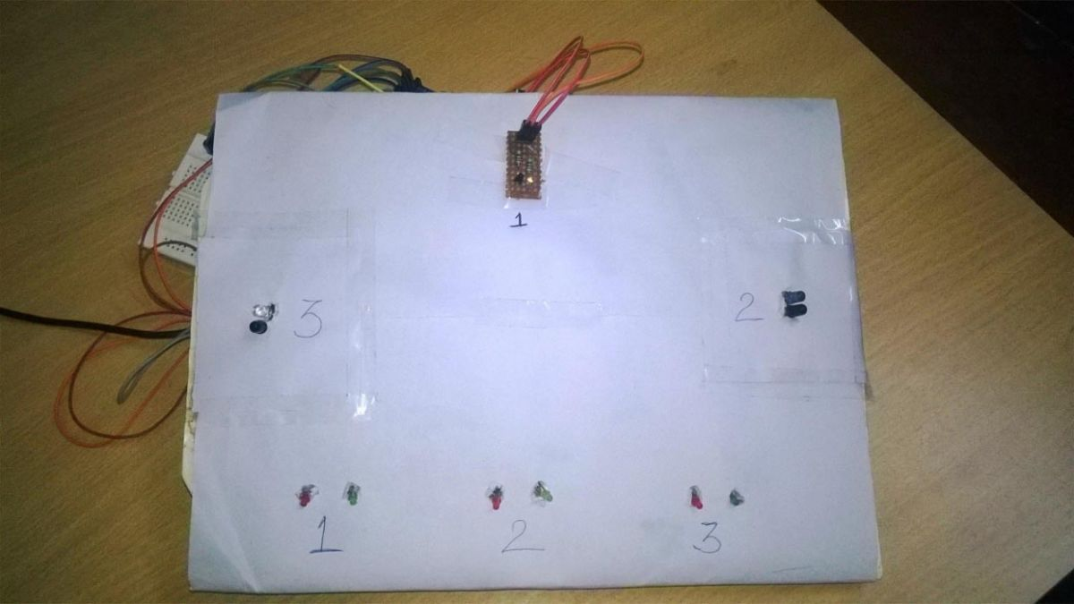

Figure 2

* 1. **Connection for the IR sensors**

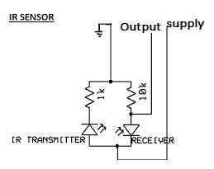

Figure 3

* 1. **Block Diagram**

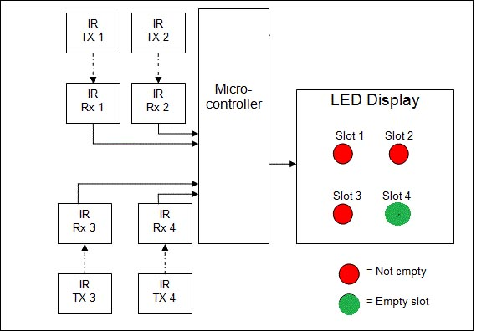

Figure 4

* 1. **Description of the Circuit**

In circuit there are 3 IR sensors are used each at 3 parking slot. These IR sensors are connected to the pin A0, A1, A2 respectively. The led’s are connected at the Digital I/O pins i.e., pin 2 for RED1, pin 3 for GREEN1, pin 4 for RED2, pin 5 for GREEN2, pin6 for RED3 and pin 7 for GREEN3.

When the slot1 will be vacant then IR receiver will not receive any signal. Hence GREEN1 will glow. If any signal is received by the IR receiver then it will be compared to the threshold value and if it is more than the threshold value then RED1 will glow. This process will be similar to all other slots.

**1.8 COMPONENTS OF SYSTEM**

**a) ARDUINO UNO**

The Arduino UNO is a widely used open-source microcontroller board based on the [Microchip](https://en.wikipedia.org/wiki/Microchip_Technology) [ATmega328P](https://en.wikipedia.org/wiki/ATmega328P) microcontroller and developed by [Arduino.cc](https://en.wikipedia.org/wiki/Arduino). The board is equipped with sets of digital and analog input/output (I/O) pins that may be interfaced to various expansion boards (shields) and other circuits. The board features 14 Digital pins and 6 Analog pins. It is programmable with the [Arduino IDE](https://en.wikipedia.org/wiki/Arduino#software) (Integrated Development Environment) via a type B USB cable. It can be powered by a USB cable or by an external 9 volt battery, though it accepts voltages between 7 and 20 volts. It is also similar to the Arduino Nano and Leonardo. The hardware reference design is distributed under a [Creative Commons](https://en.wikipedia.org/wiki/Creative_Commons) Attribution Share-Alike 2.5. Layout and production files for some versions of the hardware are also available. "Uno" means one in Italian and was chosen to mark the release of Arduino Software (IDE) 1.0.The Uno board and version 1.0 of Arduino Software (IDE) were the reference versions of Arduino, now evolved to newer releases. The Uno board is the first in a series of USB Arduino boards, and the reference model for the Arduino platform. The ATmega328 on the Arduino Uno comes preprogrammed with a bootloader that allows to upload new code to it without the use of an external hardware programmer. It communicates using the original STK500 protocol. The Uno also differs from all preceding boards in that it does not use the FTDI USB-to-serial driver chip. Instead, it features the Atmega16U2 (Atmega8U2 up to version R2) programmed as a USB-to-serial converter. The Arduino UNO is generally considered the most user-friendly and popular board or the Arduino board series, with boards being sold worldwide for less than 25$ and clones sold for less than 5$

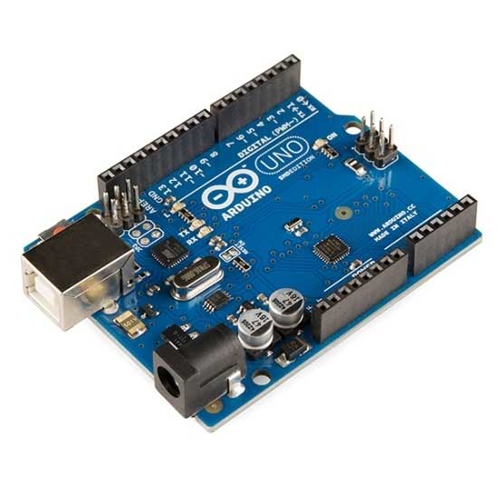

**Figure 5 Arduino UNO**

**b) IR SENSORS**

An [infrared sensor](https://www.elprocus.com/ir-remote-control-basics-operation-application/) is an electronic device, that emits in order to sense some aspects of the surroundings. An IR sensor can measure the heat of an object as well as detects the motion.These types of sensors measures only infrared radiation, rather than emitting it that is called as a [passive IR sensor](https://www.elprocus.com/passive-infrared-pir-sensor-with-applications/). Usually in the infrared spectrum, all the objects radiate some form of thermal radiations. These types of radiations are  invisible to our eyes, that can be detected by an infrared sensor.The emitter is simply an IR LED ([Light Emitting Diode](http://www.elprocus.com/explain-different-types-leds-working-applications-engineering-students/)) and the detector is simply an IR photodiode which is sensitive to IR light of the same wavelength as that emitted by the IR LED. When IR light falls on the photodiode, The resistances and these output voltages, change in proportion to the magnitude of the IR light received.

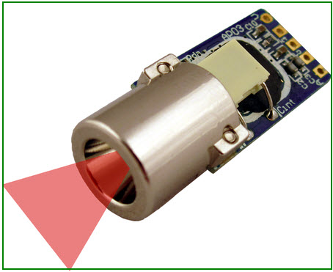

**Figure 6 IR Sensor**

## IR Sensor Circuit Diagram and Working Principle

An infrared  sensor circuit is one of the basic and popular sensor module in an [electronic device](http://www.elprocus.com/basic-components-used-electronics-electrical/). This sensor is analogous to human’s visionary senses, which can be used to detect obstacles and it is one of the common applications in real time.This circuit comprises of the following components

* [LM358 IC](http://www.elprocus.com/op-amp-ics-pin-configuration-features-working/) 2 IR transmitter and receiver pair
* Resistors of the range of kilo ohms.
* LED (Light Emitting Diode).
* Variable resistors.

[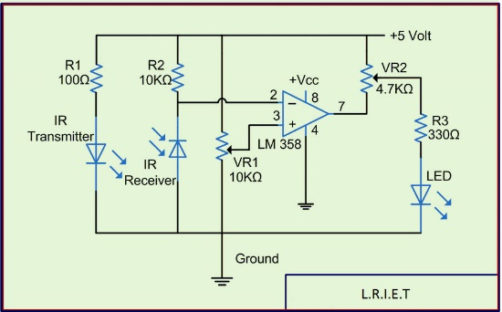](http://www.elprocus.com/wp-content/uploads/2015/01/IR-sensor-circuit-diagram.jpg)

Figure 7

**c) ESP8266 MODULE**

The **ESP8266** is a low-cost [Wi-Fi](https://en.wikipedia.org/wiki/Wi-Fi) microchip with full [TCP/ stack](https://en.wikipedia.org/wiki/TCP/IP_stack) and [microcontroller](https://en.wikipedia.org/wiki/Microcontroller) capability produced by Shanghai-based Chinese manufacturer [Espressif Systems](https://en.wikipedia.org/w/index.php?title=Espressif_Systems&action=edit&redlink=1).

The chip first came to the attention of western [makers](https://en.wikipedia.org/wiki/Maker_culture) in August 2014 with the **ESP-01** module, made by a third-party manufacturer Ai-Thinker. This small module allows microcontrollers to connect to a Wi-Fi network and make simple TCP/IP connections using [Hayes](https://en.wikipedia.org/wiki/Hayes_command_set)-style commands. However, at the time there was almost no English-language documentation on the chip and the commands it accepted. The very low price and the fact that there were very few external components on the module, which suggested that it could eventually be very inexpensive in volume, attracted many hackers to explore the module, chip, and the software on it, as well as to translate the Chinese documentation.

The **ESP8285** is an ESP8266 with 1 MiB of built-in flash, allowing for single-chip devices capable of connecting to Wi-Fi.

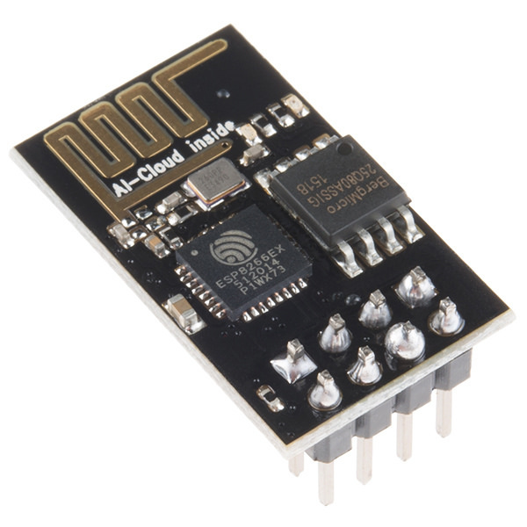

**Figure 8 ESP8266**

The ESP8266-01 has been a great module to quench all our thirsts for [IOT projects](https://circuitdigest.com/internet-of-things-iot-projects). Since its release, it has developed a strong community and evolved into an easy to use, cheap and powerful **Wi-Fi module**. Another open-source platform which is much more popular is the Arduino, it already has tons of projects built around it. Combining these two platforms will open up doors for many innovative projects, so in this tutorial we will learn **how to interface the ESP8266-01 module with Arduino**. This way we will be able to send or receive data between the Arduino and Internet.

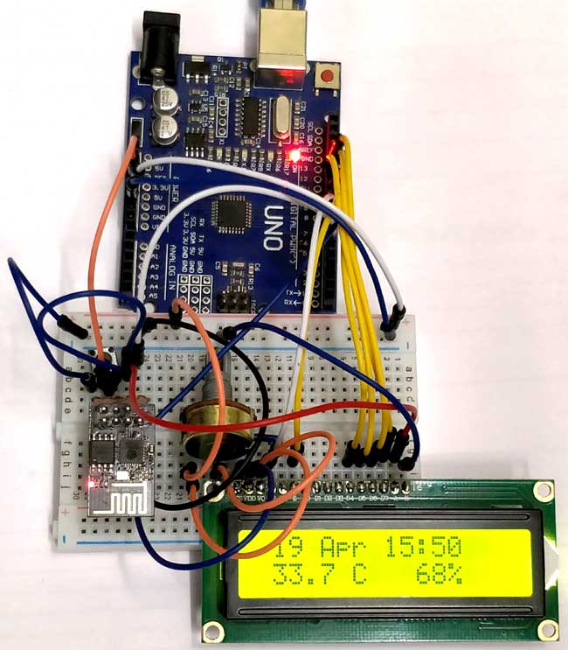

Figure 9 ESP With Wi-Fi Module

**d) 7805 IC**

Voltage sources in a circuit may have fluctuations resulting in not providing fixed voltage outputs. A voltage regulator IC maintains the output voltage at a constant value. 7805 IC, a member of 7805 series of fixed linear voltage regulators used to maintain such fluctuations, is a popular voltage regulator integrated circuit (IC). The xx in 7805 indicates the output voltage it provides. 7805 IC provides +5 volts regulated power supply with provisions to add a heat sink.

# Lm7805-pinout-diagram-300x238

**Figure 10 7805 IC**

# 7805 IC Rating

* Input voltage range 7V- 35V
* Current rating Ic =1A
* Output voltage range   VMax=5.2V ,VMin=4.8V

# Pin Details of 7805 IC

|  |  |  |  |
| --- | --- | --- | --- |
| Pin No. | Pin | Function | Description |
| 1 | INPUT | Input voltage (7V-35V) | In this pin of the IC positive unregulated voltage is given in regulation. |
| 2 | GROUND | Ground (0V) | In this pin where the ground is given. This pin is neutral for equally the input and output. |
| 3 | OUTPUT | Regulated output; 5V (4.8V-5.2V) | The output of the regulated 5V volt is taken out at this pin of the IC regulator. |

**e) RELAY MODULE**

A relay is an electrically operated switch of mains voltage. It means that it can be turned on or off, letting the current go through or not.Controlling a relay with the Arduino is as simple as controlling an output such as an LED.The relay module is the one in the figure below.

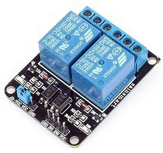

**Figure 11 Relay Module**

**Mains voltage connections**

In relation to mains voltage, relays have 3 possible connections:

* **COM**: common pin
* **NO (Normally Open):** there is no contact between the common pin and the normally open pin. So, when you trigger the relay, it connects to the COM pin and supply is provided to a load
* **NC (Normally Closed):** there is contact between the common pin and the normally closed pin. There is always connection between the COM and NC pins, even when the relay is turned off. When you trigger the relay, the circuit is opened and there is no supply provided to a load

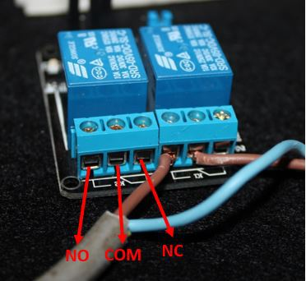

**Figure 12 Relay Connections**

**PIN WIRING**

* **GND**: goes to ground
* **IN1**: controls the first relay (it will be connected to an Arduino digital pin)
* **IN2**: controls the second relay (it should be connected to an Arduino digital pin if you are using this second relay. Otherwise, you don’t need to connect it)
* **VCC**: goes to 5V

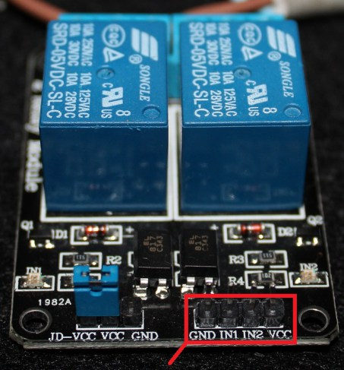

Figure 13 Pin Wiring

**f) LED**

A **light-emitting diode** (**LED**) is a two-[lead](https://en.wikipedia.org/wiki/Lead_(electronics)) [semiconductor](https://en.wikipedia.org/wiki/Semiconductor) [light source](https://en.wikipedia.org/wiki/Light_source). It is a [p–n junction](https://en.wikipedia.org/wiki/P%E2%80%93n_junction) [diode](https://en.wikipedia.org/wiki/Diode) that emits light when activated. When a suitable [current](https://en.wikipedia.org/wiki/Electric_current) is applied to the leads,[electrons](https://en.wikipedia.org/wiki/Electron) are able to recombine with [electron holes](https://en.wikipedia.org/wiki/Electron_hole) within the device, releasing energy in the form of [photons](https://en.wikipedia.org/wiki/Photon). This effect is called [electroluminescence](https://en.wikipedia.org/wiki/Electroluminescence), and the color of the light (corresponding to the energy of the photon) is determined by the energy [band gap](https://en.wikipedia.org/wiki/Band_gap) of the semiconductor. LEDs are typically small (less than 1 mm2) and integrated optical components may be used to shape the [radiation pattern](https://en.wikipedia.org/wiki/Radiation_pattern).

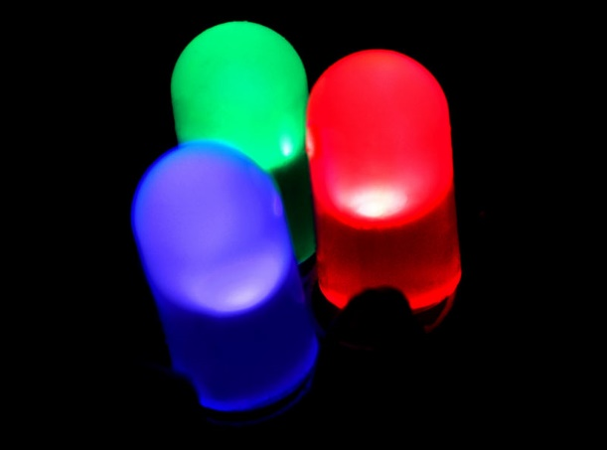

Figure 14 LED

**Advantages:**

-Energy efficient source of light for short distances and small areas. The typical LED requires only 30- 60 milliwatts to operate  
 -Durable and shockproof unlike glass bulb lamp types  
 -Directional nature is useful for some applications like reducing stray light pollution on streetlights

**Disadvantages:**

-May be unreliable in outside applications with great variations in summer/winter temperatures, more work is being done now to solve this problem  
 -Semiconductors are sensitive to being damaged by heat, so large heat sinks must be employed to keep powerful arrays cool, sometimes a fan is required. This adds to cost and a fan greatly reduces the energy efficient advantage of LEDs, it is also prone to failure which leads to unit failure  
 -Circuit board solder and thin copper connections crack when flexed and cause sections of arrays to go out  
 -Rare earth metals used in LEDs are subject to price control monopolies by certain nations   
 -Reduced lumen output over time

**g) TRANSISTOR**

A **transistor** is a [semiconductor device](https://en.wikipedia.org/wiki/Semiconductor_device) used to [amplify](https://en.wikipedia.org/wiki/Electronic_amplifier) or [switch](https://en.wikipedia.org/wiki/Switch) [electronic](https://en.wikipedia.org/wiki/Electronics) signals and [electrical power](https://en.wikipedia.org/wiki/Electrical_power). It is composed of [semiconductor](https://en.wikipedia.org/wiki/Semiconductor) material usually with at least three [terminals](https://en.wikipedia.org/wiki/Terminal_(electronics)) for connection to an external circuit. A [voltage](https://en.wikipedia.org/wiki/Voltage) or [current](https://en.wikipedia.org/wiki/Electric_current) applied to one pair of the transistor's terminals controls the current through another pair of terminals. Because the controlled (output) [power](https://en.wikipedia.org/wiki/Electric_power) can be higher than the controlling (input) power, a transistor can [amplify](https://en.wikipedia.org/wiki/Amplifier) a signal. Today, some transistors are packaged individually, but many more are found embedded in [integrated circuits](https://en.wikipedia.org/wiki/Integrated_circuit).

The transistor is the fundamental building block of modern [electronic devices](https://en.wikipedia.org/wiki/Electronic_device), and is ubiquitous in modern electronic systems. [Julius Edgar Lilienfeld](https://en.wikipedia.org/wiki/Julius_Edgar_Lilienfeld)patented a [field-effect transistor](https://en.wikipedia.org/wiki/Field-effect_transistor) in 1926but it was not possible to actually construct a working device at that time.The first practically implemented device was a [point-contact transistor](https://en.wikipedia.org/wiki/Point-contact_transistor) invented in 1947 by American [physicists](https://en.wikipedia.org/wiki/Physicist) [John Bardeen](https://en.wikipedia.org/wiki/John_Bardeen), [Walter Brattain](https://en.wikipedia.org/wiki/Walter_Brattain), and [William Shockley](https://en.wikipedia.org/wiki/William_Shockley). The transistor revolutionized the field of electronics, and paved the way for smaller and cheaper [radios](https://en.wikipedia.org/wiki/Radio), [calculators](https://en.wikipedia.org/wiki/Calculator), and [computers](https://en.wikipedia.org/wiki/Computer), among other things. The transistor is on the [list of IEEE milestones](https://en.wikipedia.org/wiki/List_of_IEEE_milestones) in electronics, and Bardeen, Brattain, and Shockley shared the 1956 [Nobel Prize in Physics](https://en.wikipedia.org/wiki/Nobel_Prize_in_Physics) for their achievement.

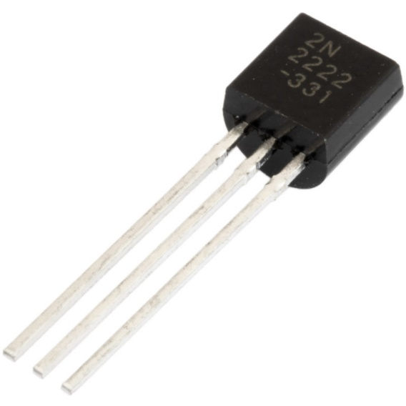

Figure 15 Transistor

A small change in the current or voltage at the inner semiconductor layer (which acts as the control electrode) produces a large, rapid change in the current passing through the entire component. The component can thus act as a switch, opening and closing an electronic gate many times per second. Today's computers use circuitry made with complementary metal oxide semiconductor (CMOS) technology. CMOS uses two complementary transistors per gate (one with N-type material; the other with P-type material). When one transistor is maintaining a logic state, it requires almost no power.

**h) RESISTANCE**

Resistance is the opposition that a substance offers to the flow of electric [current](https://whatis.techtarget.com/definition/current).  It is represented by the uppercase letter R.  The standard unit of resistance is the [ohm](https://whatis.techtarget.com/definition/ohm), sometimes written out as a word, and sometimes symbolized by the uppercase Greek letter omega: Greek letter omega

When an electric current of one [ampere](https://whatis.techtarget.com/definition/ampere) passes through a component across which a potential difference ([voltage](https://whatis.techtarget.com/definition/voltage)) of one [volt](https://whatis.techtarget.com/definition/volt) exists, then the resistance of that component is one ohm. (For more discussion of the relationship among current, resistance and voltage, see [Ohm's law](https://whatis.techtarget.com/definition/Ohms-Law).)

In general, when the applied voltage is held constant, the current in a direct-current ([DC](https://whatis.techtarget.com/definition/DC-direct-current)) electrical circuit is inversely proportional to the resistance.  If the resistance is doubled, the current is cut in half; if the resistance is halved, the current is doubled.  This rule also holds true for most low-frequency alternating-current ([AC](https://whatis.techtarget.com/definition/alternating-current-AC)) systems, such as household utility circuits. In some AC circuits, especially at high frequencies, the situation is more complex because some components in these systems can store and release [energy](https://whatis.techtarget.com/definition/energy), as well as dissipating or converting it.

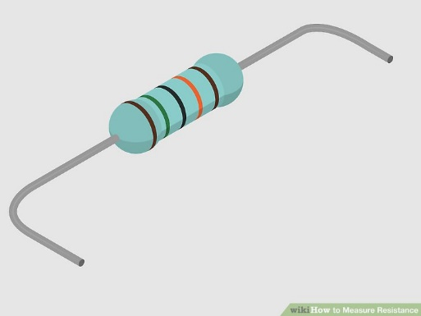

Figure 16 Resistance

**i) PRINTED CIRCUIT BOARD (PCB)**

A **printed circuit board** (**PCB**) mechanically supports and electrically connects [electronic components](https://en.wikipedia.org/wiki/Electronic_components) or [electrical](https://en.wikipedia.org/wiki/Electrical) components using [conductive](https://en.wikipedia.org/wiki/Electrical_conductor) tracks, pads and other features [etched](https://en.wikipedia.org/wiki/Industrial_etching) from one or more sheet layers of copper [laminated](https://en.wikipedia.org/wiki/Laminated) onto and/or between sheet layers of a [non- conductive](https://en.wikipedia.org/wiki/Insulator_(electricity)) [substrate](https://en.wikipedia.org/wiki/Substrate_(electronics)). Components are generally [soldered](https://en.wikipedia.org/wiki/Soldering) onto the PCB to both electrically connect and mechanically fasten them to it.

Printed circuit boards are used in all but the simplest electronic products. They are also used in some electrical products, such as passive switch boxes.

Alternatives to PCBs include [wire wrap](https://en.wikipedia.org/wiki/Wire_wrap) and [point-to-point construction](https://en.wikipedia.org/wiki/Point-to-point_construction), both once popular but now rarely used. PCBs require additional design effort to lay out the circuit, but manufacturing and assembly can be automated. Specialized CAD software is available to do much of the work of layout. Mass-producing circuits with PCBs is cheaper and faster than with other wiring methods, as components are mounted and wired in one operation. Large numbers of PCBs can be fabricated at the same time, and the layout only has to be done once. PCBs can also be made manually in small quantities, with reduced benefits.

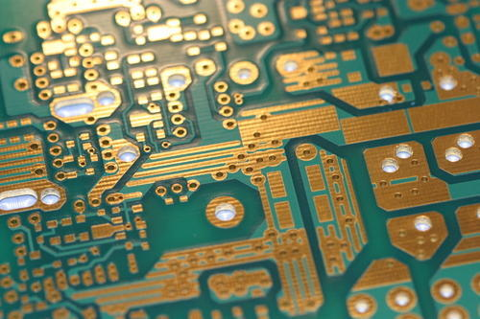

Figure 17 PCB

Through-hole manufacture adds to board cost by requiring many holes to be drilled accurately, and it limits the available routing area for [signal traces](https://en.wikipedia.org/wiki/Signal_trace) on layers immediately below the top layer on multi- layer boards, since the holes must pass through all layers to the opposite side. Once surface-mounting came into use, small-sized SMD components were used where possible, with through-hole mounting only of components unsuitably large for surface-mounting due to power requirements or mechanical limitations, or subject to mechanical stress which might damage the PCB (e.g. by lifting the copper off the board surface).

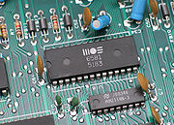

Figure 14 Through-hole devices mounted on the circuit board of a mid-1980s home computer

**j) BATTERY**

An electric battery is a device consisting of one or more [electrochemical cells](https://en.wikipedia.org/wiki/Electrochemical_cell) with external connections provided to power electrical devices such as [flashlights](https://en.wikipedia.org/wiki/Flashlight), [smartphones](https://en.wikipedia.org/wiki/Smartphone), and [electric cars](https://en.wikipedia.org/wiki/Electric_car). When a battery is supplying [electric power](https://en.wikipedia.org/wiki/Electric_power), its positive terminal is the [cathode](https://en.wikipedia.org/wiki/Cathode) and its negative terminal is the [anode](https://en.wikipedia.org/wiki/Anode). The terminal marked negative is the source of electrons that when connected to an external circuit will flow and deliver energy to an external device. When a battery is connected to an external circuit, [electrolytes](https://en.wikipedia.org/wiki/Electrolyte) are able to move as ions within, allowing the chemical reactions to be completed at the separate terminals and so deliver energy to the external circuit. It is the movement of those ions within the battery which allows current to flow out of the battery to perform work. Historically the term "battery" specifically referred to a device composed of multiple cells, however the usage has evolved additionally to include devices composed of a single cell.

[Primary](https://en.wikipedia.org/wiki/Primary_battery) (single-use or "disposable") batteries are used once and discarded; the [electrode](https://en.wikipedia.org/wiki/Electrode) materials are irreversibly changed during discharge. Common examples are the [alkaline battery](https://en.wikipedia.org/wiki/Alkaline_battery) used for [flashlights](https://en.wikipedia.org/wiki/Flashlight) and a multitude of portable electronic devices. [Secondary (rechargeable) batteries](https://en.wikipedia.org/wiki/Rechargeable_battery) can be discharged and recharged multiple times using an applied electric current; the original composition of the electrodes can be restored by reverse current. Examples include the [lead-acid batteries](https://en.wikipedia.org/wiki/Lead-acid_batteries) used in vehicles and [lithium-ion](https://en.wikipedia.org/wiki/Lithium-ion) batteries used for portable electronics such as [laptops](https://en.wikipedia.org/wiki/Laptop) and [smartphone](https://en.wikipedia.org/wiki/Smartphone).

Batteries come in many shapes and sizes, from miniature cells used to power [hearing aids](https://en.wikipedia.org/wiki/Hearing_aid) and wristwatches to small, thin cells used in [smartphones](https://en.wikipedia.org/wiki/Smartphone), to large [lead acid batteries](https://en.wikipedia.org/wiki/Lead_acid_battery) used in cars and trucks, and at the largest extreme, huge battery banks the size of rooms that provide standby or emergency power for [telephone exchanges](https://en.wikipedia.org/wiki/Telephone_exchange) and computer [data centers](https://en.wikipedia.org/wiki/Data_center).

According to a 2005 estimate, the worldwide battery industry generates US$48 [billion](https://en.wikipedia.org/wiki/1000000000_(number)) in sales each year, with 6% annual growth. Batteries have much lower [specific energy](https://en.wikipedia.org/wiki/Specific_energy) (energy per unit mass) than common [fuels](https://en.wikipedia.org/wiki/Fuel) such as gasoline. In automobiles, this is somewhat offset by the higher efficiency of electric motors in producing mechanical work, compared to combustion engines

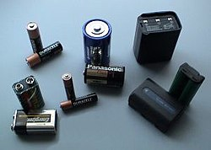

Figure 15 Battery

**1.9. APPLICATIONS**

Nowadays in many multiplex systems there is a severe problem for car parking systems. There are many lanes for car parking, so to park a car one has to look for the all lanes. Moreover there is a lot of men labor involved for this process for which there is lot of investment. So the need is to develop a system which indicates directly which parking slot is vacant in any lane. The project involves a system including infrared transmitter and receiver in every lane and a LED display outside the car parking gate. So the person entering parking area can view the LED display and can decide which lane to enter so as to park the car.

Conventionally, car parking systems does not have any intelligent monitoring system. Parking lots are monitored by human beings. All vehicles enter into the parking and waste time for searching for parking slot. Sometimes it creates blockage. Condition become worse when there are multiple parking lanes and each lane have multiple parking slots. Use of automated system for car parking monitoring will reduce the human efforts. Display unit is installed on entrance of parking lot which will show LEDs for all Parking slot and for all parking lanes. Empty slot is indicated by the respective glowing LED.

•Smart parking pilot programs are now being deployed in San Francisco, Los Angeles, Stockholm, Beijing, Shanghai, São Paulo, and the Netherlands. For example, in Los Angeles , low-power sensors and smart meters track the occupancy of parking spaces throughout the Hollywood district, one of its most congested areas.

•Users can access that occupancy data to determine the availability of spots and then pay for them with their mobile phones. In addition to lending convenience and environmental benefits, smart parking improves the utilization of existing parking, leading to greater revenue for parking owners. Los Angeles saw a return on its investment in smart parking within three months.

**CHAPTER 2**

**LITERATURE SURVEY**

* 1. **INTRODUCTION**

In today parking lots there are no standard system to check for parking spaces. The system heavily relies on human interaction with the physical space and entity. This leads to wastage of human manpower and also parking spaces at times. These parking lots are dependent on Human-to-Human Interaction (HHI) which is not efficient. Previously, various techniques have been proposed to overcome such problems. Smart parking with help of short messaging service (SMS) was devised to provide an entry and exit password which would allow the person to authenticate himself/herself at the entry/exit point. The ZigBee wireless sensor network along with global system for mobile (GSM) used a data from each node to show if the parking space is available and the data was available only at the entry point and at the administration end. The author Jihoon Yang introduced a new system with global positioning system (GPS) which helped user to locate parking space remotely. The sensors however, could not be stacked over one another . Artificial Intelligence (AI) provided a background for image processing using camera sensor which helped identify occupied parking spaces to the administrator. The Man jusha Patil proposed a system which works with passive radio frequency identification (RFID) tags which helps identifying individual cars and then booking a slot at the entrance. The image show how the system works. The author presents an idea to use wide angle camera as a sensor which will read only free parking spaces and records them. They are marked with grey spots on the screen. These records are then used to assign parking space to the incoming user.

In other works, authors have designed and implemented an SPS whose bottom part is composed of ZigBee network which sent pressure information to PC through a coordinator and then update database Shiyao et al. to solve the parking problem. A part of this system is implemented in the Zigbee network which sends urgent information to a PC through a coordinator and then updates the database. The application layer can quickly pass the parking information over the Internet, and use the advantages of a web service to gather all the scattered parking information for the convenience of those who want to find a parking space. This paper simply reports the design and implementation of an SPS and does not evaluate the system performance. Bonde et al. Aimed to automate the car and the car parking. The paper discusses a project which presents a miniature model of an automated car parking system that can regulate and manage the number of cars that can be parked in a given area at any given time based on the availability of parking spaces. The automated parking method allows the parking and exiting of cars using sensing devices. Entry to or exit from the car park is commanded by an Android based application. The difference between the Bonde system and the other existing systems is that the authors were aiming to make the system as little human dependent as possible by automating the cars as well as the entire car park; on the other hand, most existing systems require human intervention (the car owner or other) to park the car.

To avoid the cost of using parking sensors, an alternative solution Lu et.al performs parking reservation by exploiting the capabilities of vehicular ad hoc networks (VANETS). VANETs utilize wireless communication enabling cars to communicate with each other and with the roadside infrastructure. The main drawback of such technology is that it requires special equipment to be installed in cars and the roadside; it is anticipated that such deployment will take some time and therefore the aforementioned approach is not realistically implementable at present. Another concept in the area of intelligent transportation systems is the development of Parking Reservation Systems (PRs) that aim to enable drivers to reserve a parking spot prior to their trip Mouskos et al. These schemes, instead of introducing dynamic message signs that continuously update the number of available parking spaces, propose parking reservation based on the use of an optimization strategy. This paper formulates parking reservation as a binary assignment integer linear program, which can be solved through the use of any

linear programming software. Linear programming optimization is rather simple; it does not provide an efficient max-min optimization strategy-minimization of parking overlapping (satisfaction of user‘s requirements) and simultaneous maximization of parking infrastructure capability (satisfaction of parking owners). Lambrinos and Dos is described a new SPS architecture based on the Internet of Things technology. The architecture of this system consists of a Zigbee Wireless Sensor Network (WSN), an IoT middleware layer and a front-end layer as the final user interface that provides data reporting to the user. However, there are disadvantage as it does not use a suitable application protocol for the transfer of data from the WSN to the server, such as the constrained application protocol (CoAP), there is no mathematical model for the system operations, and there is no system performance evaluation. In Geng and Cassandras an approach is presented for reservation of parking slots based on the driver‘s costs. But the proposed system can not fuse the parking reservation requests and statuses with other useful data which is gathered by the cars and parking slots.

* 1. **DATA GATHERING**

For the results in this paper, we use measurements from a WSN parking sensor deployment installed and managed by Worldsensing. The deployment is comprised of N = 370 wireless sensors, where a node is located underneath each parking spot. Data were collected for six full months, from 1 December 2014 to 30 May 2015, counting more than one million parking events. With si(t) ∈{0,1}, we denote the occupancy status of sensor i at the generic time t, where si(t) = 0 andsi(t) = 1 respectively mean that the corresponding parking spotis vacant and busy at time t. In this paper, we are concerned with the statistics of parking events, namely their duration, which is modeled for sensor i through the non-negative random variable (r.v.) tiON, and the duration of vacancies, modeled through the non-negative r.v. tiOFF. In what follows, for any parking space, we respectively refer to “ON” and “OFF” as the parking states corresponding to busy and vacant. With TiON and TiOFF, we indicate TiOFF = E[tiOFF] and TiON = E[tiON], respectively. In Figure 1, the empirical probability density function(pdf)of tON is plotted against a heavy-tailed Weibull distribution(similar results hold for tOFF). Although the empirical pdf shows an oscillatory pattern, which smooths out for increasing values of the abscissa, the Weibull nicely captures the general trend. These results are also conﬁrmed by experimental data from the Smart Santander WSN deployment; see [24,26].

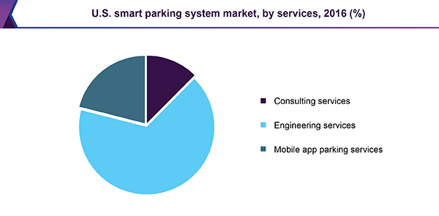

Figure 18

**CHAPTER 3**

**THE PROPOSAL/ METHODOLOGY**

* 1. **INTRODUCTION**

In Smart Parking System an Infrared sensor will sense the position of car and entry gate will open and infrared through operational amplifier will send an amplified signal to controller and controller will send empty locations on LCD and RTC will start to record the time interval of parking where reed switch will sense the position if its occupied or not forming a magnetic switch ( Reed Switch ).

♣LED will show the status of Parking Slots.

♣Whenever a car want to take exit then it will go to exit gate again the Infrared sensor will sense the position of car and send an amplified signal to controller and gate will open and again LCD will display the fare of parking duration.

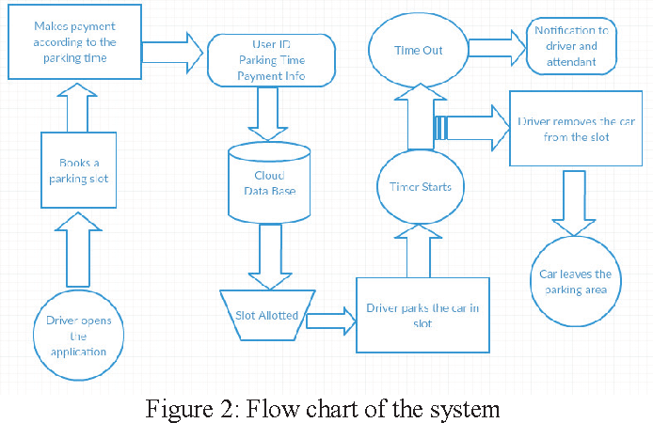

We conducted an experiment in order to depict the working of our system at every stage from checking the availability of parking space to actually park a car in a vacant parking slot. This is done by implementing the smart parking system in the parking area of a shopping mall. Below are the steps that a driver needs to follow in order to park its car using our parking system.

**Step 1**: Insall the smart parking application on your mobile device.

**Step 2**: With the help of the mobile app search for a parking area on and around your destination. x **Step 3**: Select a particular parking area.

**Step 4**: Browse through the various parking slots available in that parking area.

**Step 5**: Select a particular parking slot.

**Step 6**: Select the amount of time (in hours) for which you would like to park your car for.

**Step 7**: Pay the parking charges either with your ewallet or your credit card.

**Step 8**: Once you have successfully parked your car in the selected parking slot, confirm your occupancy using the mobile application.

The International Standards Organization (ISO) Human Centred Design for Interactive Systems Specifies six principles of a user centered design approach:

• The design is based upon an explicit understanding of users, tasks and environments.

• Users are involved throughout design and development.

• The design is driven and refined by user-centered evaluation.

• The process is iterative.

• The design addresses the whole user experience.

• The design team includes multidisciplinary skills and perspectives.

**3.2 Panoramic View of the Methodology**

Incorporating the recommendations above, we have placed the users squarely at the core of both the design process and product implementation. We have actively sought the suggestions and input of key stakeholders in framing the design and intend to reflect their input with regards to usability and evaluating the product’s value added post deployment. The key advantage of the user- centric design is that a more thorough understanding of the nontechnical factors that affect the use of the technology to be deployed emerges by involving stakeholders and users. This ensures that the product is effective – in terms of addressing the deficit it is intend to correct, and efficient – in terms of usability issues. The iterative process between users and the design team also promotes buy-in and a sense of ownership. In addition, carrying stakeholders and end users along and making them an integral part of the process allows for a better management of their expectations. It is made up of four stages of a broadly conceived product development life cycle itemized below:

• Specify the nature and if possible, magnitude of the present deficit;

• Design of the socio-technical system;

• Implementation of the design and;

• Post Deployment evaluation.

Stage 1 is the focus of the present research effort and entails the identification of key stakeholders and obtaining input from them with regards to the existing parking situation with the City of Pittsburgh. In addition, information is sourced from them with regards to their expectations of the planned application. This information is subsequently used to specify the nature and magnitude of existing system deficits.

In stage 2, the profile of the deficit constructed is passed to the product development team whose objective is to reflect this insight in the product’s design. Oftentimes, this will be a two-way street in that various iterations of the design, for example, paper prototypes or a simulated, non-operational software prototypes are shared with the stakeholders and the back and forth process ceases only when

stakeholders feel sufficiently comfortable with the design. On the part of the design team, this process fosters a deeper understanding of the intended use of application while stakeholders end up having a greater sense of ownership.

The next stage will be the deployment of an operational prototype for the pilot deployment phase. The objective here is to observe how end users interact with the product, evaluate usability metrics, and address efficiency issues before the application is scaled up. We envisage surveying between 500 - 1000 end users to collect data on these issues.

Some of these issues could be addressed by modifying the product’s design in its present iteration while others may be more involved, requiring changes to be made to the product’s design. A baseline of relevant performance metrics will also be collected before product deployment. Stage 4 focuses on the product’s effectiveness. Once the product5 is rolled out, post deployment metrics are calculated and compared to the baseline ones in order to establish the product’s value- added. This latter part is done in a summative sense and could be couched as answering the question – has the application been successful in addressing the identified deficit?

**CHAPTER 4**

**SIMULATION RESULTS AND ANALYSIS**

**4.1 INTRODUCTION**

Yue Xin intelligent high performance wireless connectivity platform --ESCP SOC, designers bring the Gospel to the mobile platform, it At the lowest cost to provide maximum usability for WiFi capabilities embedded in other systems offer unlimited possibilities.

**4.1.1 TECHNICAL OVERVIEW**

ESP8266 is a complete and self-contained Wi-Fi network solutions that can carry software applications, or through Another application processor uninstall all Wi-Fi networking capabilities.

ESP8266 when the device is mounted and as the only application of the application processor, the flash memory can be started directly from an external Move.

Built-in cache memory will help improve system performance and reduce memory requirements.

Another situation is when wireless Internet access assume the task of Wi-Fi adapter, you can add it to any microcontroller-based design, the connection is simple, just by SPI / SDIO interface or central processor AHB bridge interface.

Processing and storage capacity on ESP8266 powerful piece, it can be integrated via GPIO ports sensors and other applications specific equipment to achieve the lowest early in the development and operation of at least occupy system resources.

The ESP8266 highly integrated chip, including antenna switch balun, power management converter, so with minimal external circuitry, and includes front-end module, including the entire solution designed to minimize the space occupied by PCB.

The system is equipped with ESP8266 manifested leading features are: energy saving VoIP quickly switch between the sleep / wake patterns, with low-power operation adaptive radio bias, front-end signal processing functions, troubleshooting and radio systems coexist characteristics eliminate cellular / Bluetooth / DDR / LVDS / LCD interference.

**4.1.2 Characteristics**

802.11 b / g / n

Wi-Fi Direct (P2P), soft-AP

Built-in TCP / IP protocol stack

Built-in TR switch, balun, LNA, power amplifier and matching network

Built-in PLL, voltage regulator and power management components

802.11b mode + 19.5dBm output power

Built-in temperature sensor

Support antenna diversity

off leakage current is less than 10uA

Built-in low-power 32-bit CPU: can double as an application processor

SDIO 2.0, SPI, UART

STBC, 1x1 MIMO, 2x1 MIMO

A-MPDU, A-MSDU aggregation and the 0.4 Within wake

2ms, connect and transfer data packets

standby power consumption of less than 1.0mW (DTIM3)

**4.2 WORKING OF APPLICATION**

This section describes the high level architecture for the smart parking system along with a mathematical model. The parking system that we propose comprises of various actors that work in sync with one another. Below is the mathematical model that defines our smart parking system.

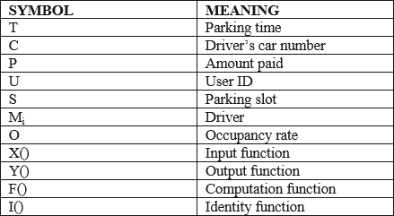

Mi ĺ X(T,C,P,U,S) // Driver provides input to the input function

X()ĺF(S,T) // Input function notifies the computation function

X()ĺI(P,C,U) // Input function notifies the identity function

Oi= F(S,T)ĺY() // Computation function notifies the output function and the resultant is stored in form of the occupancy rate.

Oi= 0Ň1 // Occupancy rate can either be 0 or 1. Where 0 specifies occupied and 1 means vacant.

We conducted an experiment in order to depict the working of our system at every stage from checking the availability of parking space to actually park a car in a vacant parking slot. This is done by implementing the smart parking system in the parking area of a shopping mall. Below are the steps that a driver needs to follow in order to park its car using our parking system.

**CHAPTER 5**

**CONCLUSION AND FUTURE SCOPE**

**5.1 CONCLUSION**

The concept of Smart Cities have always been a dream for humanity. Since the past couple of years large advancements have been made in making smart cities a reality. The growth of Internet of Things and Cloud technologies have give rise to new possibilities in terms of smart cities.

Smart parking facilities and traffic management systems have always been at the core of constructing smart cities. In this paper, we address the issue of parking and present an IoT based Cloud integrated smart parking system.

The system that we propose provides real time information regarding availability of parking slots in a parking area. Users from remote locations could book a parking slot for them by the use of our mobile application.

The efforts made in this paper are indented to improve the parking facilities of a city and thereby aiming to enhance the quality of life of its people.

This energy saving display system employee a single column of multi-color LED‟s, rotating a high enough speed to be indistinguishable for human eye. Hence the display appears to be constantly illuminated and brilliant color image can be seen from any angle of view.

After completing the process of implementation of both hardware and software, followed by a rigorous testing phase, we can conclude that the spinning LED display appropriately displayed a visible message without blurs, flickering, or delays once the motor reached desired speed.

Further it also confirmed that the keypad also worked as expected, allowing a programmable message and the ability to designate color .Thus we can say that spinning LED display system using radio frequency as mode of communication will have an efficient and satisfying display quality compared to tradition dot matrix LED scrolling text systems.

* 1. **FUTURE SCOPE**

The smart parking industry continues to evolve as an increasing number of cities struggle with traffic congestion and inadequate parking availability.

While the deployment of sensor technologies continues to be core to the development of smart parking, a wide variety of other technology innovations are also enabling more adaptable systems— including cameras, wireless communications, data analytics, induction loops, smart parking meters, and advanced algorithms.

They're in the ground all over the country, in parking lots and city streets. They're small and unobtrusive little guys, like small discs flat on the ground or the reflector bumps like you might drive over when crossing lanes. These are simple devices with a straightforward task, and they're about to have a huge impact on the way drivers in U.S. cities park, just by knowing when cars are parked over them and when they're not.

"It's an industry that’s been completely overlooked from a technology perspective," says Zia Yusuf. He's the CEO at Streetline, a company that specializes in implementing what are being called intelligent parking systems. These are wirelessly connected networks of sensors and computer systems that accurately track the availability of parking spaces and enable variable pricing that changes with demand. The idea is to better inform drivers about where they can find parking to help reduce congestion on streets, up to a third of which has been blamed on drivers searching for open parking spaces.

"The impact on all of us and the impact on cities is pretty profound," says Yusuf.

On a regular street, drivers can circle around and around looking for a spot, which means one more car on the road (and driving slowly, at that), and one more combustion engine emitting greenhouse gases into the environment. The goal of intelligent parking systems is to know where parking is available and to let the driver know as well, making it easier for cars to find their way into parking spots.

Another goal is to understand just where parking is in demand and when. For cities, this information can be extremely useful.

"This is a piece of real estate that isn't priced appropriately, that isn’t allocated appropriately," says Yusuf. "Parking is generally the second or third largest source of revenue for a city. So there's a significant financial impact to this."

With connected metering systems and the embedded ground sensors in parking spaces, cities can, in real time, know which streets are packed with parked cars and which streets have plenty of empty spaces. Knowing this can help the city change pricing on the streets to encourage drivers to either avoid high-priced (and highly congested) areas, or, it's also hoped, to consider a transportation option that doesn't require parking in the first place.

This system is based on the ideas of UCLA professor Donald Shoup, laid out in his well-known urban planning tome The High Cost of Free Parking. San Francisco recently became the first major city to act on the advice of Shoup, implementing its [SF Park](http://sfpark.org/how-it-works/) system. On-street parking spaces and city-owned garages are equipped with meters so the city can track occupancy rates and adjust pricing throughout the day. The city installed the system in 2010 and began varying its pricing last summer. The goal is to redistribute the demand for parking throughout the city. Web and phone applications make it easy for drivers to locate parking spots that are both open and at the desired price point.

The system is currently in a test phase in 7,000 of the city's on-street parking spaces, and more than 12,000 spaces in city-owned garages, part of a pilot phase that runs through the summer. The project was largely funded through a grant from the U.S. Department of Transportation, and it's expected that more of the city's metered spaces and garages will fold into the system after the pilot.

Other cities have been paying attention to San Francisco, and now a handful have implemented their own intelligent parking system pilot projects. Streetline is behind many of these projects, including pilots in Boston, Fort Worth, New York, and Washington, D.C. [Streetline recently launched another pilot program in Indianapolis, a city

**5.2.1 Moving Toward Automation**

The future of the smart parking market is expected to be significantly influenced by the arrival of automated vehicles (AVs). Several cities around the world are already beginning to trial self-parking vehicles, specialized AV parking lots, and robotic parking valets.

For example, in Boulder, Colorado, [ParkPlus](http://www.parkplusinc.com/index-parkplus.php) is working on [deploying a fully automated parking garage](http://denverurbanreview.com/2015/05/boulders-innovative-pearlwest-makes-headway/) in the Western United States through Boulder’s PearlWest mixed-use development.

The company’s automated parking system uses lasers to scan cars and a robotic valet to park the vehicles. Vehicles are transported by a robotic dolly that lifts and transfers them to storage racks. Using this system, up to 4 times as many cars can be parked in the same amount of space as a traditional garage (since there is no need for extra space in between cars).

The automated system is expected to deliver vehicles within 3-5 minutes of a retrieval request.

**5.2.2 Development and Deployment**

In 2018, a small fleet of cars with piloted parking technology will be deployed to test self-parking capabilities with a specialized nearby parking garage. The idea is that having cars that self-park will help improve traffic congestion considerably as riders could be dropped off in front of their destination and the car would park itself and minimize the time spent taking up space on the road (as opposed to drivers circling several blocks continuously looking for a space).

In 2020, phase two of the project is expected to commence with the deployment of a full fleet of self- parking Audi cars. By 2030, the self-parking garage is targeting availability to the broader AV market. It is estimated that [parking garages specifically designed for self-parking cars can take up 60% less space](https://www.audiusa.com/newsroom/news/press-releases/2015/11/audi-brings-automated-parking-to-the-boston-area) than traditional lots (as cars can park much closer together and elevators and stairs are no longer required).

Leading smart cities are recognizing that smart parking infrastructure (i.e., sensors and communications networks) can be leveraged to help enable cars of the future to park themselves. AV fleets are also expected to fundamentally change the way cars are used, affecting how often and where future vehicles will be parked. For more information on the smart parking industry, check out Navigant Research’s recently released report, [Smart Parking Systems](http://www.navigantresearch.com/research/smart-parking-systems).

**REFERENCES**

[1] Rico, J., Sancho, J., Cendon, B., & Camus, M. (2013, March). Parking easier by using context information of a smart city: Enabling fast search and management of parking resources. In Advanced Information Networking and Applications Workshops (WAINA), 2013 27th International Conference on (pp. 1380-1385). IEEE.

[2] Zheng, Y., Rajasegarar, S., & Leckie, C. (2015, April). Parking availability prediction for sensor- enabled car parks in smart cities. In Intelligent Sensors, Sensor Networks and Information Processing (ISSNIP), 2015 IEEE Tenth International Conference on (pp. 1-6). IEEE.

[3] Zhou, F., & Li, Q. (2014, November). Parking Guidance System Based on ZigBee and Geomagnetic Sensor Technology. In Distributed Computing and Applications to Business, Engineering and Science

(DCABES), 2014 13th International Symposium on (pp. 268-271). IEEE.

[4] Botta, A., de Donato, W., Persico, V., & Pescapé, A. (2014, August). On the Integration of Cloud Computing and Internet of Things. In Future Internet of Things and Cloud (FiCloud), 2014 International Conference on (pp. 23-30). IEEE.

[5] Ji, Z., Ganchev, I., O'droma, M., & Zhang, X. (2014, August). A cloudbased intelligent car parking services for smart cities. In General Assembly and Scientific Symposium (URSI GASS), 2014 XXXIth URSI (pp. 1-4). IEEE.

[6] International Parking Institute, “2012 Emerging Trends in Parking”.

[7] Ballon, P., Glidden, J., Kranas, P., Menychtas, A., Ruston, S., & Van Der Graaf, S. (2011, October). Is there a Need for a Cloud Platform for European Smart Cities?. In eChallenges e-2011 Conference Proceedings, IIMC International Information Management Corporation.

[8] FastPark System website, <http://www.fastprk.com>.

[9] Chen, S. Y., Lai, C. F., Huang, Y. M., & Jeng, Y. L. (2013, July). Intelligent home-appliance recognition over IoT cloud network. In Wireless Communications and Mobile Computing Conference (IWCMC), 2013 9th International (pp. 639-643). IEEE.

[10] Dash, S. K., Mohapatra, S., & Pattnaik, P. K. (2010). A survey on applications of wireless sensor network using cloud computing. International Journal of Computer science & Engineering Technologies (E-ISSN: 2044-6004), 1(4), 50-55.

[11] Fox, G. C., Kamburugamuve, S., & Hartman, R. D. (2012, May). Architecture and measured characteristics of a cloud based internet of things. InCollaboration Technologies and Systems (CTS), 2012 International Conference on (pp. 6-12). IEEE.

[12] Han, D. M., & Lim, J. H. (2010). Smart home energy management system using IEEE 802.15. 4 and zigbee. Consumer Electronics, IEEE Transactions on, 56(3), 1403-1410.

[13] Parwekar, P. (2011, September). From Internet of Things towards cloud of things. In Computer and Communication Technology (ICCCT), 2011 2nd International Conference on (pp. 329-333). IEEE.

[14] Rao, B. B. P., Saluia, P., Sharma, N., Mittal, A., & Sharma, S. V. (2012, December). Cloud computing for Internet of Things & sensing based applications. In Sensing Technology (ICST), 2012 Sixth International Conference on (pp. 374-380). IEEE.

[15] Wikipedia website, <https://en.wikipedia.org/wiki/MQTT>.

[16] Suciu, G., Vulpe, A., Halunga, S., Fratu, O., Todoran, G., & Suciu, V. (2013, May). Smart cities built on resilient cloud computing and secure internet of things. In Control Systems and Computer Science (CSCS), 2013 19th International Conference on (pp. 513-518). IEEE.

[17] Ye, X., & Huang, J. (2011, December). A framework for cloud-based smart home. In Computer Science and Network Technology (ICCSNT), 2011 International Conference on (Vol. 2, pp. 894-897). IEEE.

[18] Zaslavsky, A., Perera, C., & Georgakopoulos, D. (2013). Sensing as a service and big data. arXiv preprint arXiv:1301.0159.

[19] Doukas, C., Capra, L., Antonelli, F., Jaupaj, E., Tamilin, A., & Carreras, I. (2015, January). Providing generic support for IoT and M2M for mobile devices. In Computing & Communication TechnologiesResearch, Innovation, and Vision for the Future (RIVF), 2015 IEEE RIVF International Conference on (pp. 192-197). IEEE.

[20] Tsirmpas, C., Anastasiou, A., Bountris, P., & Koutsouris, D. A new method for profile generation in an Internet of Things environment: An application in ambient assisted living.

[21] Kafle, V. P., Fukushima, Y., & Harai, H. (2015, April). ID-based communication for realizing IoT and M2M in future heterogeneous mobile networks. In Recent Advances in Internet of Things (RIoT), 2015 International Conference on (pp. 1-6). IEEE.

[22] Sarkar, C., Uttama Nambi SN, A., Prasad, R., Rahim, A., Neisse, R., & Baldini, G. (2012). DIAT: A Scalable Distributed Architecture for IoT.